A.I Lab Manual By Saqib Hussain

Roll No: BIT-23F-014

Python Programming Tasks (lab no 4)

**1. Arithmetic Operations on Two Numbers**

# Input two numbers  
num1 = float(input("Enter first number: "))  
num2 = float(input("Enter second number: "))  
  
# Perform arithmetic operations  
print("Addition:", num1 + num2)  
print("Subtraction:", num1 - num2)  
print("Multiplication:", num1 * num2)  
print("Division:", num1 / num2)  
print("Modulus:", num1 % num2)  
print("Exponentiation:", num1 ** num2)

***Output:***

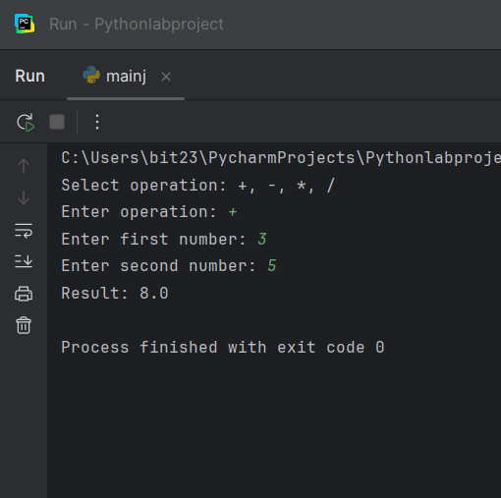

**2. Function for Arithmetic Operations**

def arithmetic_operations(a, b):  
 return a + b, a - b, a * b, a / b  
  
# Example usage  
sum_, diff, prod, quot = arithmetic_operations(20, 4)  
print("Sum:", sum_)  
print("Difference:", diff)  
print("Product:", prod)  
print("Quotient:", quot)

***Output:***

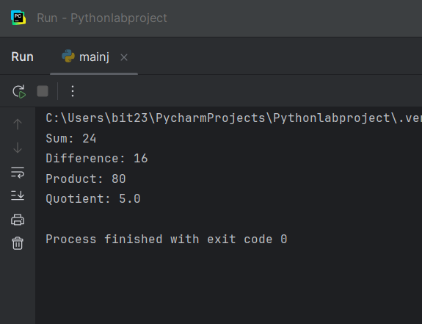

**3. Find Remainder of Division**

# Input two numbers  
num1 = int(input("Enter dividend: "))  
num2 = int(input("Enter divisor: "))  
  
# Find remainder  
remainder = num1 % num2  
print("Remainder:", remainder)

***Output:***

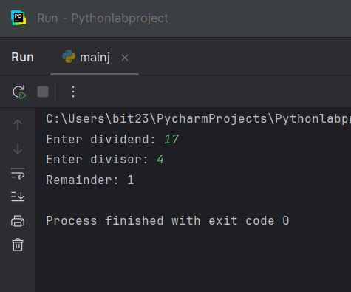

**4. Area of a Circle**

import math  
  
# Input radius  
radius = float(input("Enter the radius of the circle: "))  
  
# Calculate area  
area = math.pi * radius ** 2  
print("Area of the circle is:", area)

***Output:***

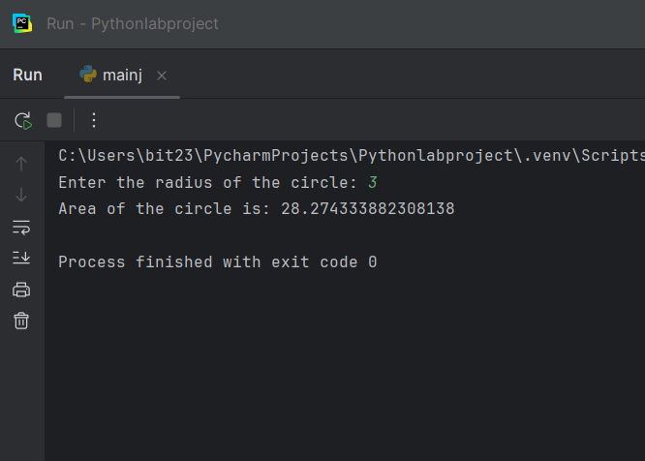

**5. Square and Cube using Exponentiation**

# Input number  
num = int(input("Enter a number: "))  
  
# Calculate square and cube  
square = num ** 2  
cube = num ** 3  
  
print("Square:", square)  
print("Cube:", cube)

***Output:***

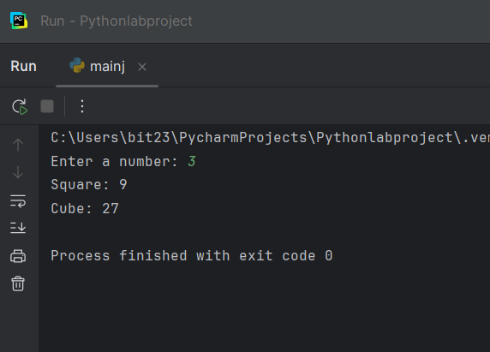

**6. Simple Calculator**

def calculator():  
 print("Select operation: +, -, *, /")  
 op = input("Enter operation: ")  
 a = float(input("Enter first number: "))  
 b = float(input("Enter second number: "))  
  
 if op == '+':  
 print("Result:", a + b)  
 elif op == '-':  
 print("Result:", a - b)  
 elif op == '*':  
 print("Result:", a * b)  
 elif op == '/':  
 if b != 0:  
 print("Result:", a / b)  
 else:  
 print("Error: Division by zero.")  
 else:  
 print("Invalid operation.")  
  
calculator()

***Output:***

